Loops Worksheet AP CSP Name___KEY_______
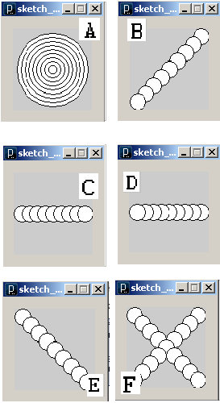
Match each program to the corresponding output.
1. C
x = 10
while x < 91:
ellipse(x,50,20,20)
x = x + 10

2. D
x = 90
while x > 9:
ellipse(x,50,20,20)
x = x - 10

3. E
x = 10
while x < 91:
ellipse(x,x,20,20)
x = x + 10

4. A
m = 90
while m > 9:
ellipse(50,50,m,m)
m = m - 10

5. F
x = 10
while x < 91:
ellipse(x,x,20,20)
ellipse(100 - x,x,20,20)
x = x + 10

6. B
x = 10
while x < 91:
ellipse(100 - x,x,20,20)
x = x + 10
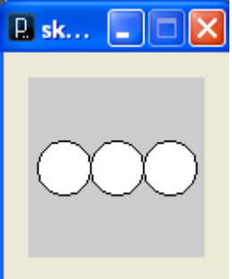
7. Complete the following program so that it produces a pattern of circles similar to that shown

x = ____20____

while x < ___81_______:

ellipse(___x_____,____50_____,30,30)

x = x + ____30__________

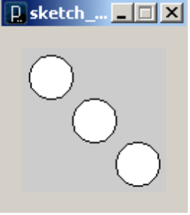
8. Make another program similar to #7, except have the three circles arranged diagonally like this:

x = 20

while x < 81:

ellipse(x,x,30,30)

x = x + 30

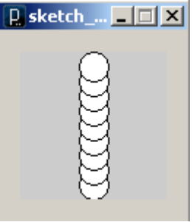
9. Write a program to make a pattern of 9 circles with y coordinates 90, 80, 70, 60, 50, 40, 30, 20, 10. You will have to make the loop “go backwards” so that the circle with a y coordinate of 90 is drawn first.

y = 90

while y > 9:

ellipse(50,y,20,20)

y = y - 10

